Aerial image (as at 12 September 2019)

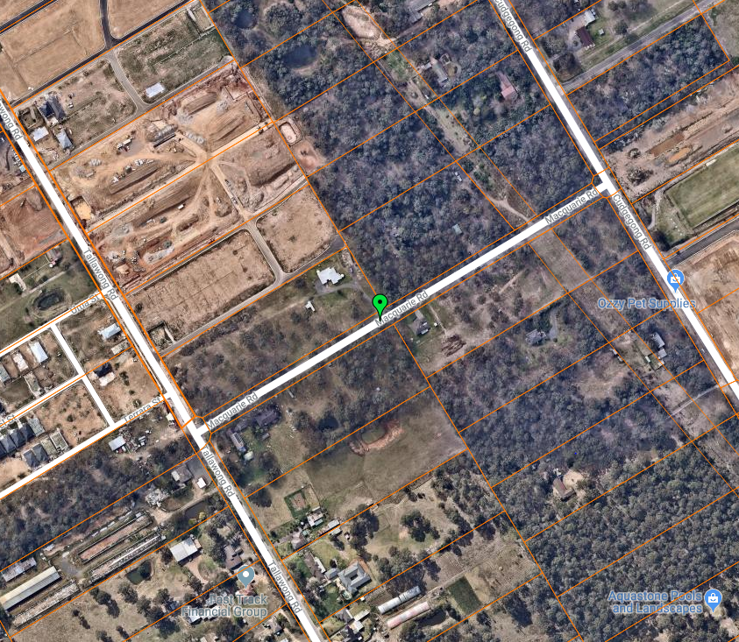

## Subject Land